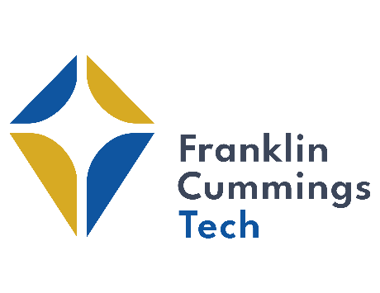
Choosing the Right Campus Visit!
Not every path is the same, and sometimes you need to see yourself on a road to know it’s the right one. At Franklin Cummings Tech, we take pride in building a community that allows everyone to explore their next steps. A campus visit lets prospective students see themselves as part of our community and allows them to explore new opportunities that they may not have considered before.
A campus visit can bridge the gap between who students are today with who they can be tomorrow. Below are our visit options:
 | Discovery Days | Group Tours | Individual Visits
Campus Tour | ✔ | ✔ | ✔
Meet with an Admissions Counselor | ✔ | ✔ | ✔
Financial Aid Counseling |  |  | ✔
On-the-Spot Admissions |  | With transcripts available | With transcripts available
Lunch Provided | ✔
Meet the Faculty | ✔ | When Available | When Available
Student Panels & Interviews | ✔
Hands-on Mini Lessons | ✔
How to Schedule | RSVP here or email our admissions office | Email our admissions office 2 weeks in advance | Email our admissions office

You can reach our Admissions Office at admissions@franklincummings.edu or by phone at 617-588-1368.

